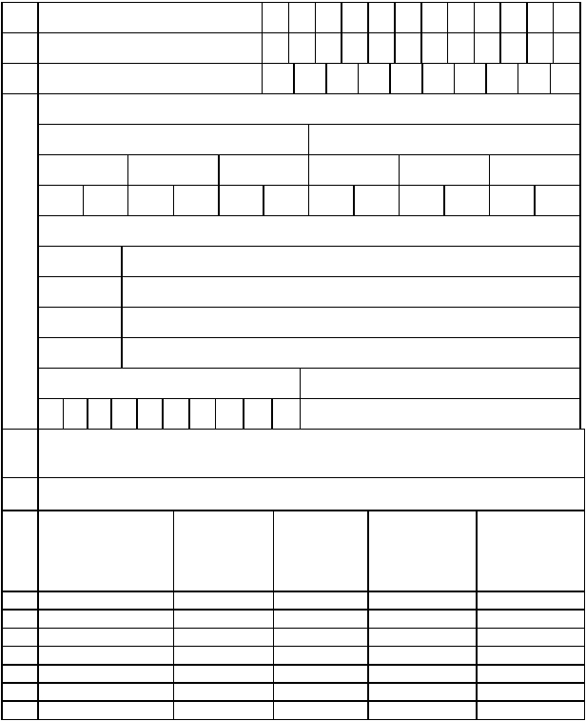
FORM 405
(See rule 40(1)(a) & (d)
Return showing Tax Deduction at Source by an employer
under-section 31 of the Maharashtra Value Added Tax Act, 2002.

1) M.V.A.T. R.C. No. (TIN), if any

2) C. S.T. R.C. No. , If any

3) Permanent Account Number

4) Period Covered by Return

FROM TO

DATE MONTH YEAR DATE MONTH YEAR

Name and Address of the Dealer
Name
Address

TELEPHONE/MOBILE NUMBER E-mail Id of the Employer

5) Details of the sum payable/paid to the contractors and amount of tax deducted/deductible
at source during the period of this return

(A) If the contractor is Registered under MVAT Act, 2002.

Amount

Sr.
No.
Name of the
Contractor
Address of the
Contractor
R.C. No./TIN
of the
contractor
Paid/Payable to
the Contractor
or Sub-
Amount of Tax
Deducted/
Deductible

contractor

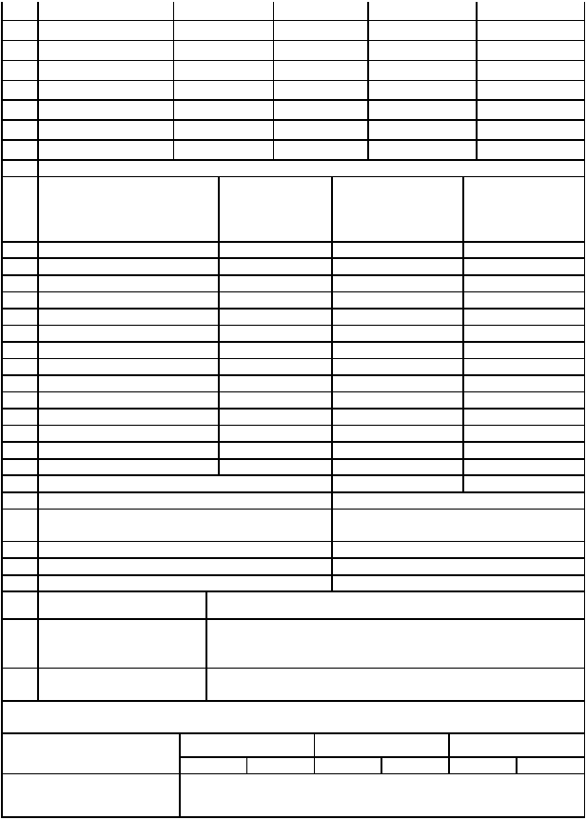
Total -A
B. If the contractor is un-registered under the MVAT Act, 2002

Sr.
No. Name of the Contractor Address of the

Contractor
Amount
Paid/Payable to the
Contractor or Sub-
contractor
Amount of Tax
Deducted/
Deductible

Total -B
Total amount Deducted/Deductible (A+B)
6) Payment made or Tax Deducted at Source
(a) Tax Deducted or Deductible at Source and
payable in Chalan in Form 210.
(b) Add:- Interest payable
(c) Total Amount Payable (a+b)
7) Total Amount Paid in Chalan in Form 210
(a) Amount (in Figures) Rs.__________________________________________
(b) Amount (in Words) Rs._________________________________________
_________________________________________

8) Amount paid as per
Rs.__________________________________________

Revised or Fresh Return
The Statements contained in this return in Boxes 1 to 8 are true to the best of my knowledge
and belief.
Date of Filing Return Date Month Year

Name and the
Authorised person

Designation
Place

Signature of the Tax payer or
of Authorised person.

